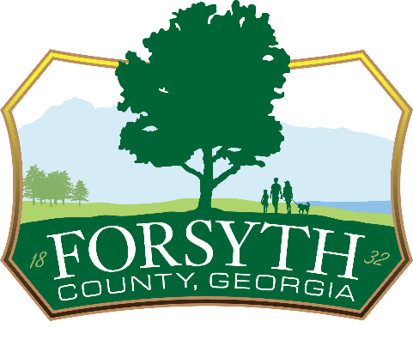
FORSYTH COUNTY
ENERGY EXCISE TAX
OCGA 48-13-110
County Ordinance 119

Due Date – 20th of each month
Information
Business Name:
Address:

Reporting Month/Year:

Computation of Tax
- Total sales of energy sold to exempt manufacturers | 1
- Less Vendor Compensation (3% of first $3,000 & .5% thereafter) | 2
- Net taxable sales | 3
- Tax Rate-2% taxable sales as outlined in Ordinance 119 | 4
- Energy Excise Tax Due | 5
Remit to
Forsyth County Finance Department
110 East Main Street
Suite 255
Cumming, GA 30040

Signature
I certify that the information provided above is accurate and in accordance with Georgia Laws 48-13-110 through 114 and the ordinances of the Unified Government of Forsyth County, Georgia known as Forsyth County.

Name: Signature

Title Date

